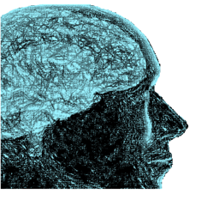

1st Automatic Assessment
of Parkinsonian Speech Workshop
AAPS’2019

September 20th-21st, Cambridge, USA

CONSENT TO PUBLISH
In order to protect copyright of works published by the Universidad Politécnica de Madrid against unauthorized use, it is necessary consent to publish from contributors. This form is for the purpose of giving such consent. Please sign and return it to the volume editors(s) named below.

Title of contribution: ___________________________________________________

Author(s): ___________________________________________________________

Title of Work: | Proceedings of the 1st Automatic Assessment of Parkinsonian Speech Workshop
Editor(s): | S. Shattuck-Hufnagel & J.I. Godino-Llorente

In consideration for publication of the contribution in this Work, the undersigned Author hereby assigns to the Universidad Politécnica de Madrid the copyright in the said contribution, whereby Universidad Politécnica de Madrid shall have the exclusive right to publish the contribution and/or translation of it throughout the world during the full term of copyright, including renewals and/or extensions, and all subsidiary rights.
The undersigned Author shall, however, retain the right to republish his/her part of the Work in any scholarly/scientific journal or in a volume consisting solely of his/her own writings, subject only to notifying Universidad Politécnica de Madrid of his/her intent to do so and to his/her ensuring that the publication by Universidad Politécnica de Madrid is properly credited and that the copyright notice is repeated verbatim. The undersigned Author guarantees that his/her contribution to the Work has not been previously published elsewhere, or that if it has been published in whole or in part, any permission necessary to publish it in the Work has been obtained and provided to Universidad Politécnica de Madrid together with the original copyright notice.

Signature: Date:

NAME:
ADDRESS:
CITY: |  | POSTAL CODE:
COUNTRY:

